|  |  |  |  |  |  |  |  |  |  |
| --- | --- | --- | --- | --- | --- | --- | --- | --- | --- |
| **SCHOOL OF COMPUTER SCIENCE AND ARTIFICIAL INTELLIGENCE** | | | | | **DEPARTMENT OF COMPUTER SCIENCE ENGINEERING** | | | | |
| **ProgramName:**B. Tech | | | | **SET-A** | | | **AcademicYear:**2025-2026 | | |
| **Roll No.** | | | |  | | | | | |
| **Instructor(s)Name** | | | | 1. Dr. Venkataramana 2. Dr. Ch. Sridhar 3. Mr. Kundan | | | | | |
| **CourseCode** | | | 24CS002PC215 | **CourseTitle** | | AI Assisted Coding | | | |
| **Year/Sem** | | | II/I | **Regulation** | | R24 | | | |
| **Date and Day**  **of Assignment** | | | 22.08.2025 | **Time(s)** | | 01.00PM To 03.00PM | | | |
| **Duration** | | | 2 Hours | **Applicableto**  **Batches** | | 24BTCAIAIB09, 24BTCAIAIB10 | | | |
| **Lab Test :1**(Present test number)/**4**(Total number of tests) | | | | | | | | | |
|  | | | | | | | | | |
|  | **Q.No.** | **Question** | | | | | | ***ExpectedTime***  ***to complete*** |  |
|  | 1 | **Task Description#1**   * Write Python function with the help of GitHub Copilot and VS Code to classify the people based on Age Group. And explain the code with required comments     **Expected Output#4**   * Age_Classifies function   **Task Description#2**   * Write Python program in cursor AI for **student class** with attributes like Name, Roll no, Marks and also construct a method i.e., **display_details** to display name, rollno and marks   **Expected Output#5**   * Student Class and Display Details   **Note: Report should be submitted a word document for all tasks in a single document with prompts, comments & code explanation, and output screenshots**  **Evaluation Criteria:**   | **Criteria** | **Max Marks** | | --- | --- | | Factorial Function (Task#1) | 5 | | Sorting Function (Task#2) | 5 | | Viva | 5 | | **Total** | **15 Marks** | | | | | | | 22.08.2025 03.00PM |  |

PROMPT 1: develop a python function that should classify people based on their age my requirements are the function name should be age classifies and input should be given by the user?

**CODE FOR THIS PROMPT:**

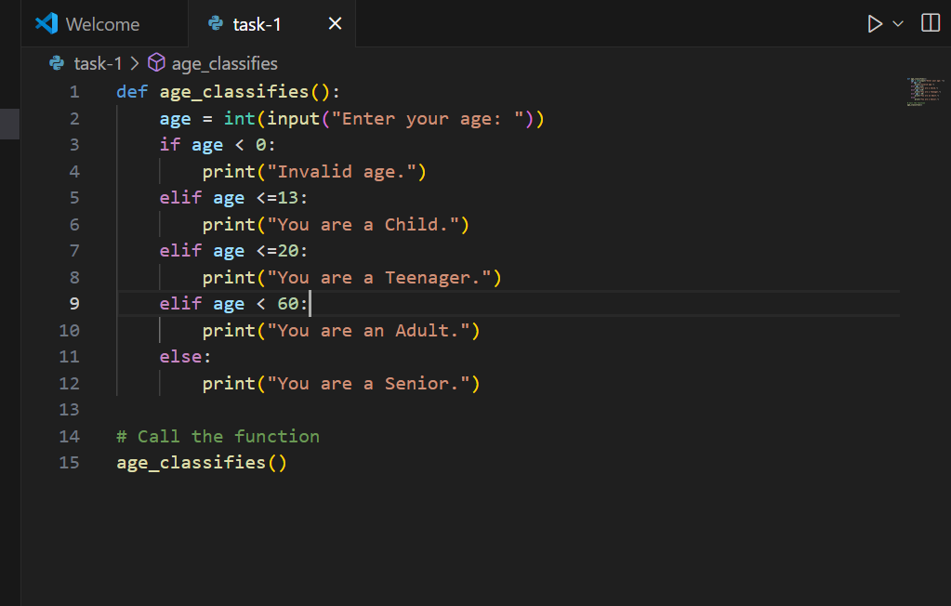

**OUTPUT:** 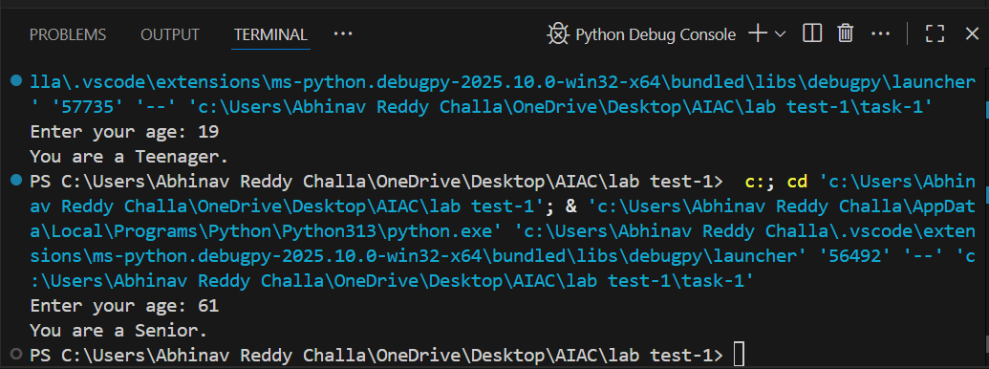

**EXPLANATION FOR THIS CODE:** This code asks the user to enter their age and then prints a message classifying them as a Child, Teenager, Adult, or Senior based on their age. If the age is negative, it prints "Invalid age."

**Task2:**

**PROMPT 2:Develop a python function about student attributes like name,rollno,marks and also construct a method i.e display details to display name,rollno,marks.my requirements are function name should be student class and display details input should be given bythe user?**

**CODE FOR THE PROMT2:**

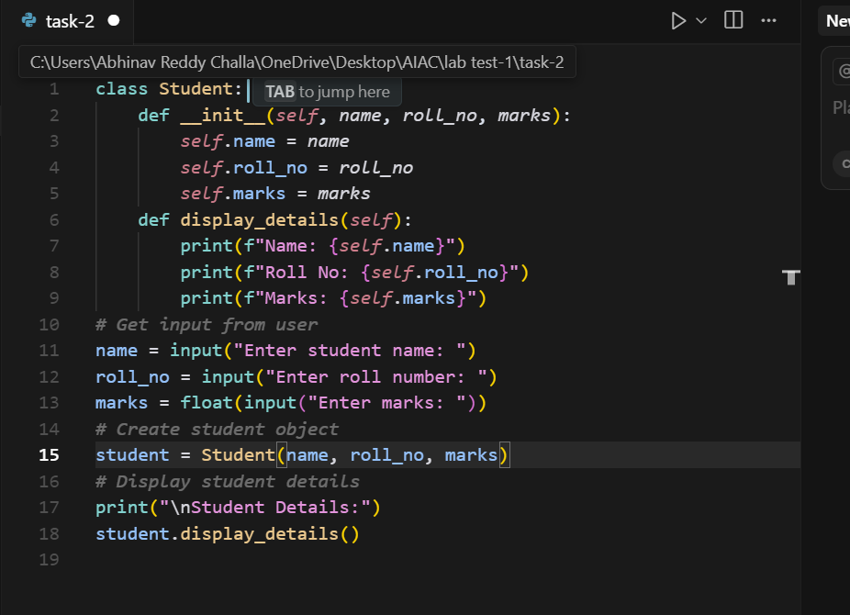

**OUTPUT:** 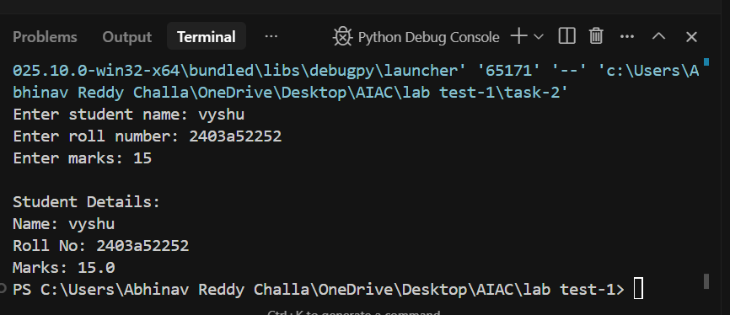

EXPLANATION FOR THIS CODE: **This code defines a Student class to store a student's name, roll number, and marks. It takes input from the user for these details, creates a Student object, and then prints the student's information using the display_details method**.